**Unit 1: Numeric Arrays TASK 1**

from array import* #tells computer to use array library.

#Creates array and prints out the array ⬇️

nums = array ('i',[45,324,654,46,264])

print (nums)

#Line breaker ⬇️

for x in nums:

print(x)

#Creates new variable which lets you add a value to the array⬇️

NewValue = int (input ("Enter number: "))

nums.append(NewValue)

print(nums)

#Makes the array in reverse order and prints it⬇️

nums.reverse()

print ("This is the list in reverse ",nums)

#This code sorts the array in ascending order⬇️

nums = sorted(nums)

print ("This is the list in ascending order ",nums)

#This deletes the last integer from the array⬇️

nums.pop()

print ("This deletes the last value",nums)

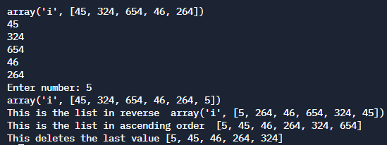

2D ARRAY TASK 2

from array import * #tells computer to use array library

import random #tells computer to use random library

num1 = array('i',[]) #creates a new variable array called num1. Empty variable.

num2 = array('i',[]) #creates a new variable array called num2.

for i in range (0,3): #for loop has been created to run set amount of time (3)

num = int (input ("Enter a number: ")) #user enters a value (3 times)

num1.append(num) #values of num gets appended/added to num1

for i in range (0,5): #for loop has been created to run set amount of time (5)

num = random.randint(1,100) #Random value from (1-100) to num (5 times)

num2.append(num) #num is appended/added to num2

num1.extend(num2) #num2 gets added onto num1

num1 = sorted(num1) #num1 gets sorted in ascending order.

for i in num1: #for loop used for set amount of time (values of num1)

print(i) #prints i

**2D Array TASK 3**

from array import*

nums = array('i',[])

while len (nums) < 5:

num = int (input ("Enter a number from 10 - 20: "))

if num >= 10 and num <= 20:

nums.append(num)

else:

print ("out of range")

print ("Thank you")

for i in nums:

print(i)

